Instructions for Adjusting the Day Care Hours of Operation

Log into the website at <http://outreach.cs.dal.ca/daycare/wp-login.php>

**Hours of operation:**

This feature displays the hours of operation in an organized table. Sections include “Day”, “From”, and “To” with all 7 days of the week (Monday – Sunday).

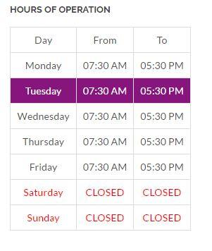  
  
**Administration:**Follow the steps below to make changes to the hours of operation feature:  
  
1- Go to the main administration panel on WordPress, and click on ‘Business Hours” found in the left side Menu.   
  
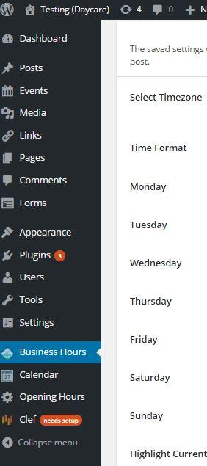

2- Select the time zone you would like to choose, and select the opening hours by each day of the week using the input boxes on the left, and the closing time using the input boxes at the right.

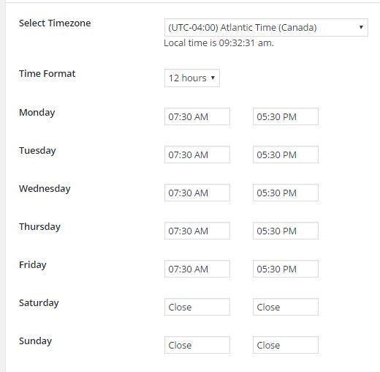

3- To change the background color of the current day of the week on the hours of operation table. Select the “Select Color” button.

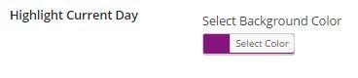

4- Choose a specific color by moving the small white circle in the color area, or by choosing one of the basic colors at the bottom, shaped as squares. Once your complete click any area outside the field area to close the select color option (Shown below).

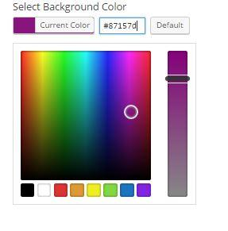

5- To change the font color of the text in the hours of operation table. Select “Current Color”. And follow the same steps as shown above in section 4.  
  
6- Once you’re finished with updating the table simply select the button at the very bottom left of the page “Save Changes”.